Theme: A young explorer finds themselves in the midst of a vast cave network. The caves are laced with puzzles and challenges that must be solved. Clearly someone was here before, and didn’t want something to be found.

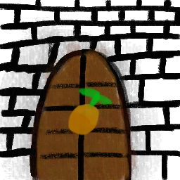
Short story: Upon entering the cave network, the explorer finds themselves boxed in. The caves seem like intentional catacombs, build from brick and with torches still burning. The entrance way narrows and leads down a single extending hallway. Eventually they stumble upon what looks to be a doorway to another section, but it’s closed. The doorway has a picture painted onto it of … an orange. The fruit. The explorer tries to open the door but it doesn’t budge. Exploring an offshoot, they find an odd almost button like extrusion in the wall, also painted with an orange. The smell of citrus consumes the room, and in the corner, a basket of oranges. Pressing the extrusion does nothing at all. With no other way out, the explorer decides to try something bizzare. Throwing the orange. The fruit hits the wall and splats, spraying juice on the walls. A loud creaking sound can be heard, the the ground trembles a bit. Returning to the main passageway, the explorer finds the door wide open, and continues through. A huge maze begins to open up, and exploring it reveals more fruit doors and puzzles to solve.

Core mechanics: A puzzle game where the player must navigate a maze-like area to find the exit. Certain areas are blocked off by doors which must be unlocked by throwing certain fruit at buttons. The maze will implement a ‘fog of war’ mechanic where the player must explore areas to be able to see them.

Scope: The project must be finished in ~2 weeks, so no super advanced features or puzzles are necessary. A single map divided by doorways will make up the game world. Keeping extra features like health, enemies, and additional items out of scope unless there’s extra time will help keep on schedule.

Technical items: The game will be implemented in the 2.5D style, blending 2D and 3D elements for a retro style and easy modeling. Defold (www.defold.com) is the engine of choice, as it is very lightweight and supports both 2D and 3D. Additionally, some libraries will be used to help with the development.
- https://defold.com/assets/lightandshadows/
- https://defold.com/assets/orthographic/
- https://defold.com/assets/tiled/
- https://defold.com/assets/druid/
- https://github.com/Dragosha/defold-things/tree/master/3d-tilemap https://defold.com/assets/kinematicwalker/
Orthographic camera which will follow the player around while they explore the map. WASD keys to move around and space or click to throw fruit.

UX Flow:
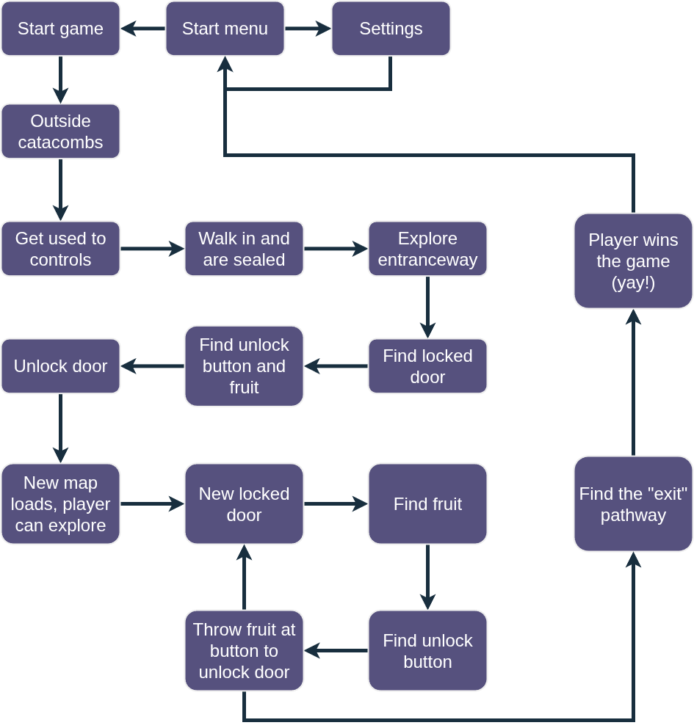
Largely self-guided experience focusing on walking through the maze and finding the exit. There is an introductory flow to get the player antiquated with the controls.

Moodboard:

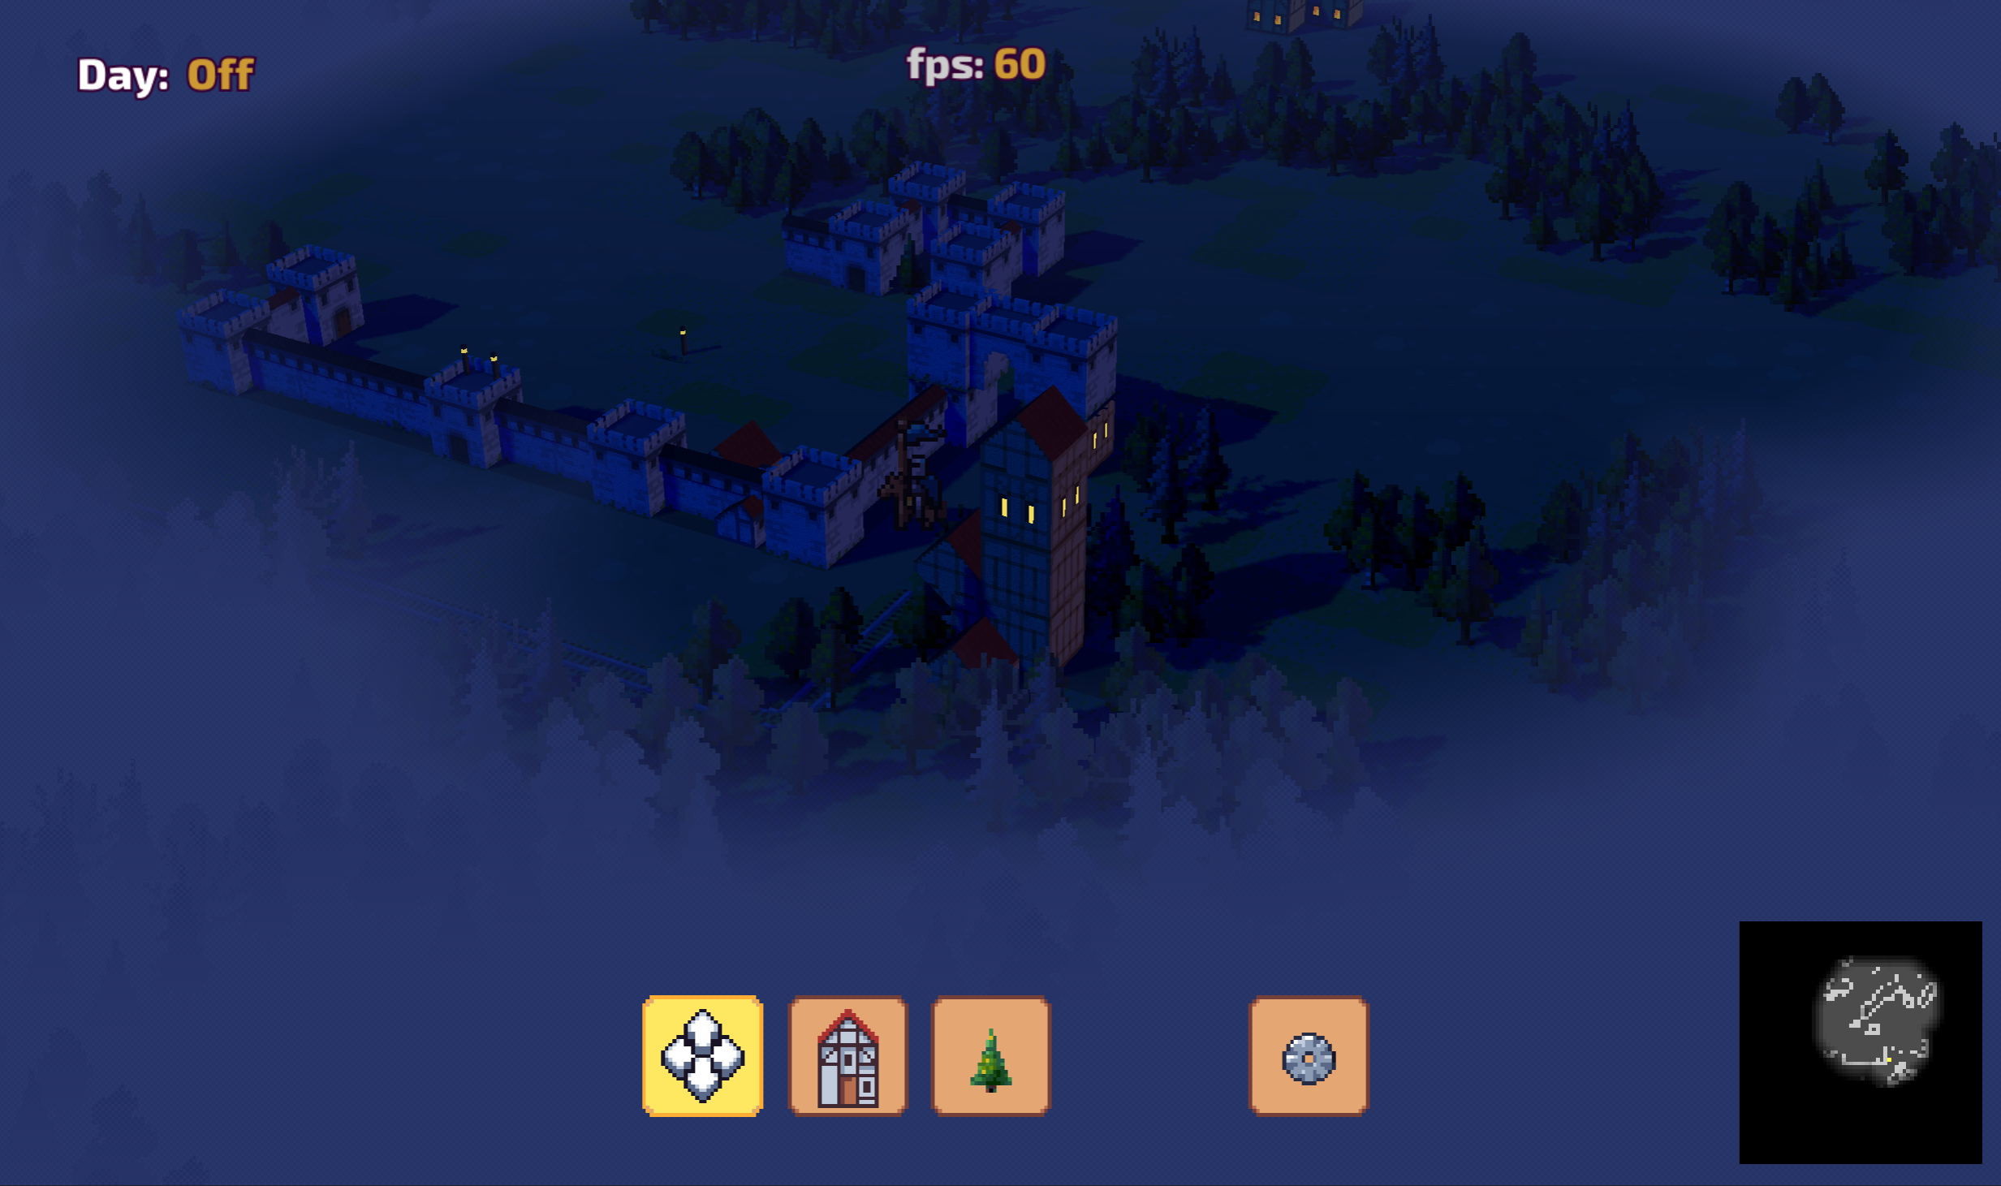
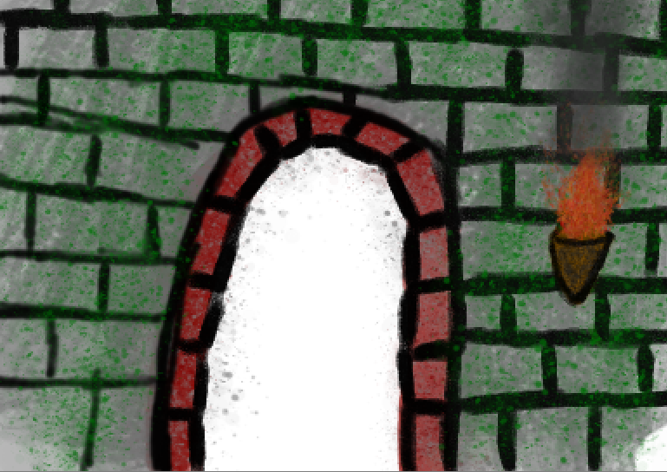
Example demo for the fog of war module from defold-lights-and-shadows
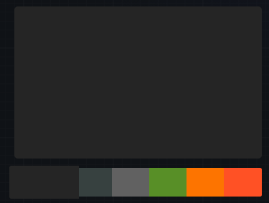
Color palate

Sketch of a doorway on brick wall

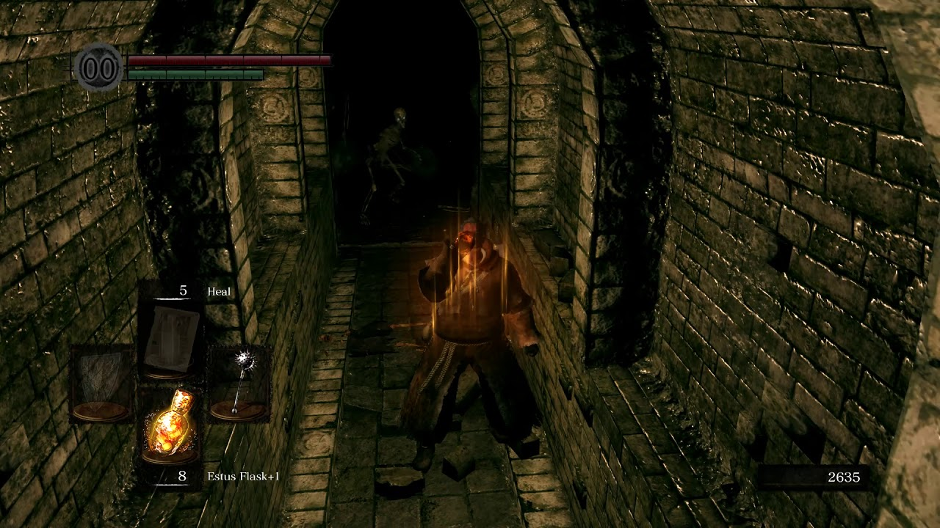
The catacombs from Dark Souls

